

**Table of Contents**

|  |
| --- |
| Version History |
| Game Description |
| Controls |
| Interface |
| Game World |
| Level |
| Enemies |
| Weapons |
| Scoring |

Version History – Part B

Initial Commit – Repository Made

Starter Code of the Assignment uploaded

Created Player with joystick movement

Created Enemies with basic AI

Worked on the Map such as platforms, and walls

Created water area with separate working gravity

Major update on Sprites

Created Menus such as Main, Instruction, Win and Lose Menu.

Player and map sprites have been changed.

New Button Sprite added for menus.

Instruction Menu changed.

New form of attack implemented.

Detailed Game Description

Game is a basic 2d platformer game where player tries to reach top of the map where the mountain is before losing all lives by the skeletons. Player can jump on it and kill the enemies. When player falls from the map or gets hit by the enemy, it will respawn where the last spawn point was and lose 1 life. Player will have total 3 lives.

Controls

Player movement are done by the joystick moving right, left, and up.

Interface Sketches

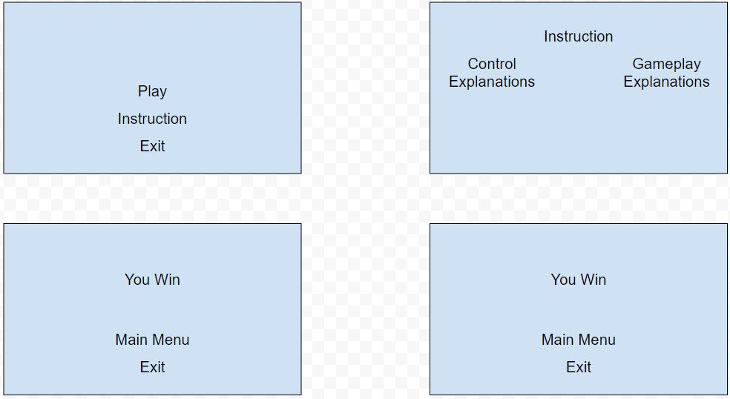

Screen Descriptions – Include at least 4 screen shots for your game: 1 for your Start Screen, 1 for your Gameplay Screen, 1 for your Game-End Screen and 1 for each level of difficulty (4 Marks: External Documentation).

Game World

Normal Platform – Where the player stands on. It is a safe area of the map, but enemies will patrol around it.

Water – Player’s gravity will decrease, and player’s horizontal and vertical force will also decrease so that player will move slower than when they are on the platforms

Death Planes – When player falls off from the map, they will lose 1 life and respawn where the last spawn point was.

Levels

Going to have a single level with multiple platforms guiding the player upward.

Characters

An Adventurer with attack, crouch, idle, jump, and run animations

Enemies (AI)

Enemies will constantly patrol around the platform.

Weapons

Player can kill the enemy by having them within player’s attack range, or by jumping on them.

Scoring (or Progression)

Player’s Progression is saved via fireplace which is a respawn point of the game. Once they reach a specific fireplace within the game, they will no longer spawn where they used to spawn and will spawn where the last fireplace was.